Joining the Virtual Ward Forum Meeting (Microsoft Teams Event Live)
A simple guide to assist residents to join the public meeting.
- Click on the link for the meeting:
https://teams.microsoft.com/l/meetup-join/19%3ameeting_MTQ3NGRmNDctNDNjNy00ZTcyLTkxZjMtZmJmOWVlZDczOTBk%40thread.v2/0?context=%7b%22Tid%22%3a%22699ace67-d2e4-4bcd-b303-d2bbe2b9bbf1%22%2c%22Oid%22%3a%22057a6077-ff63-4854-81e8-c14d4ea21e6f%22%2c%22IsBroadcastMeeting%22%3atrue%7d

2. If you have the Microsoft Teams application downloaded, click “Launch it now”. If you don’t, if this doesn’t work or if would prefer not to use it, you can watch the event on the internet instead, to do this, click “Watch on the web instead”.
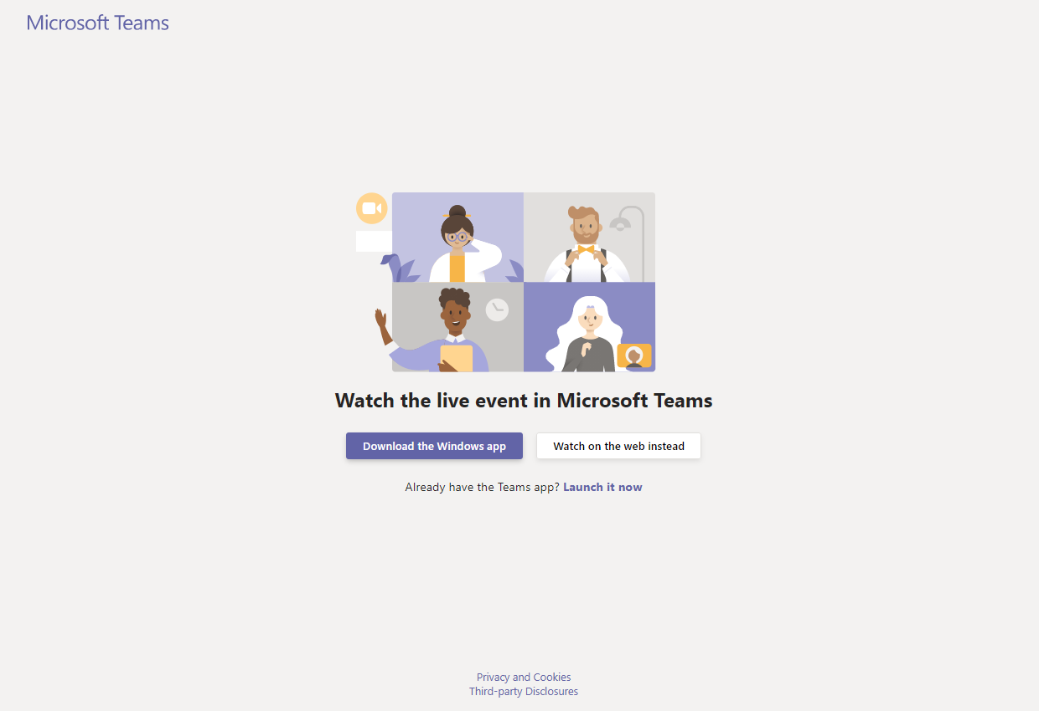

3. If you are having trouble logging in, or would not like to sign in, then please “Join anonymously”.

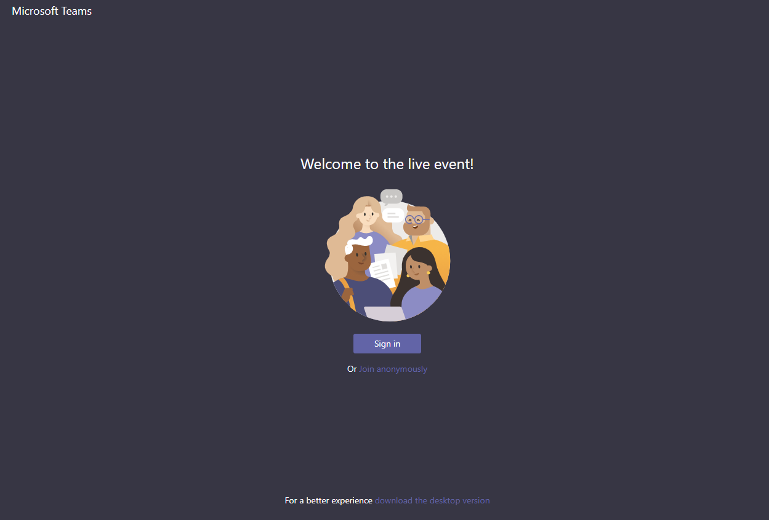

4. Whether you have joined on the Microsoft Teams application or on the web, you should then be able to see the following page, where you will see the meeting when it starts. To ask a question, please use the Q/A function – “Ask a question”.
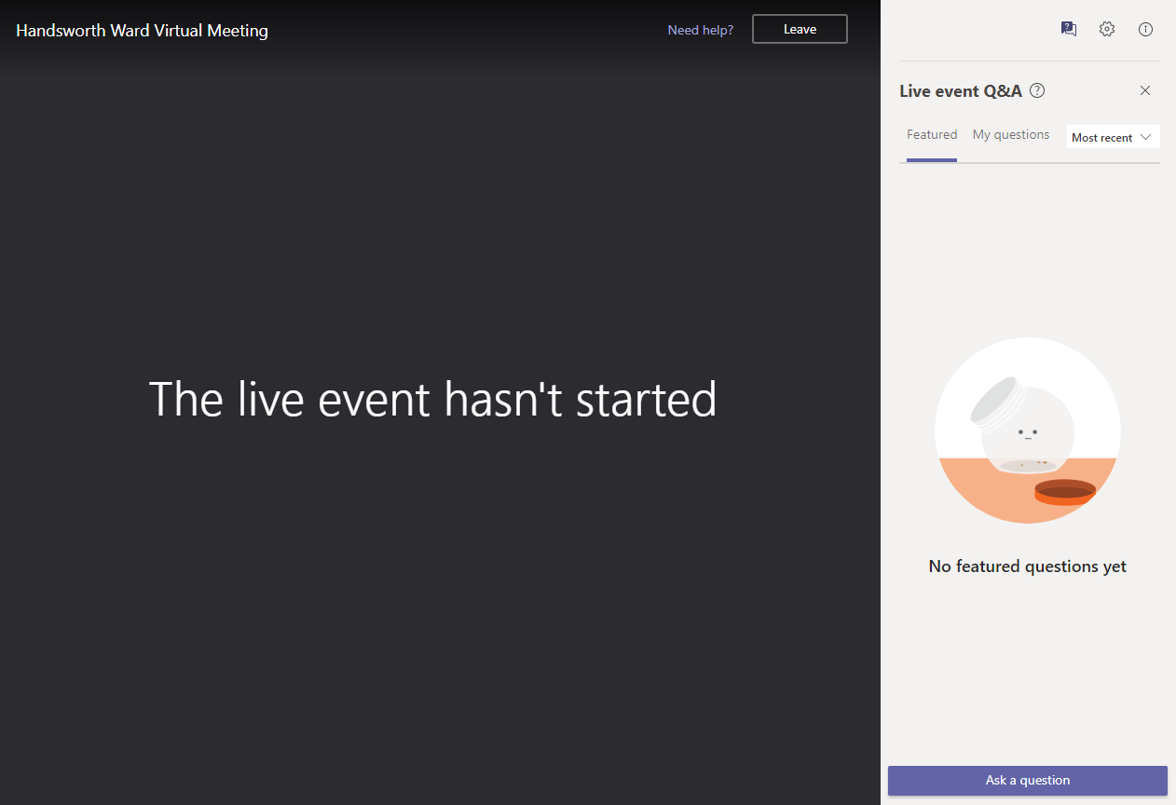
5. To ask a question, please add your name (if you wish) and add in your question underneath. To post, please use the button on the right (circled below).
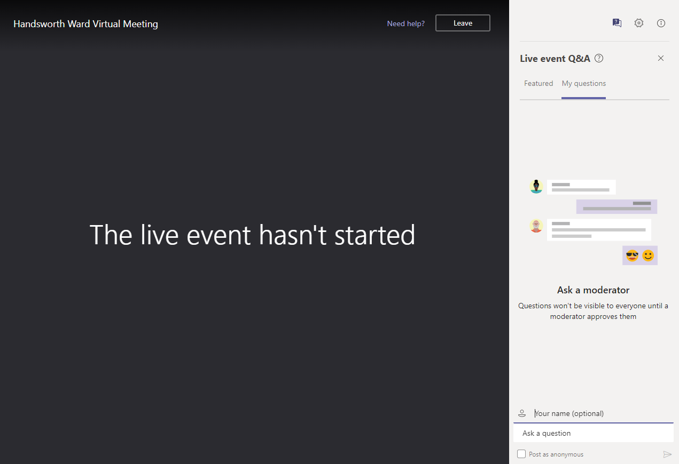
Your questions will be seen in “My questions”. To see other questions asked by attendees, please use the “Featured” option.

